**OUTCOME ATTAINMENT REPORT**

**UG ADMISSION YEAR: 2019**

Contents

CO – PO MAPPING TABLE (SAMPLE) 3

CO – PSO MAPPING TABLE (SAMPLE) 4

OUTCOME ATTAINMENT CONSOLIDATED REPORT 6

TAXONOMY ATTAINMENT REPORT 7

PO ATTAINMENT REPORT 7

PSO ATTAINMENT REPORT 8

CO ATTAINMENT REPORT 8

% CO ATTAINMENT 8

# CO – PO MAPPING TABLE (SAMPLE)

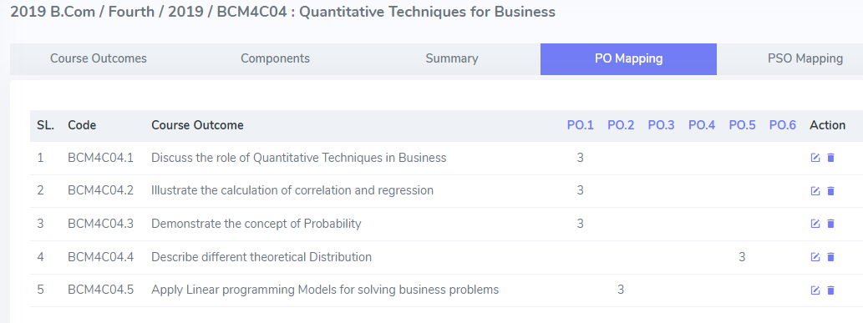

# CO – PSO MAPPING TABLE (SAMPLE)

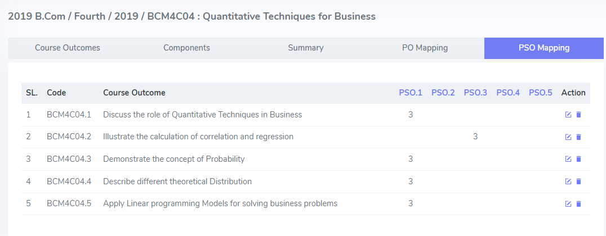

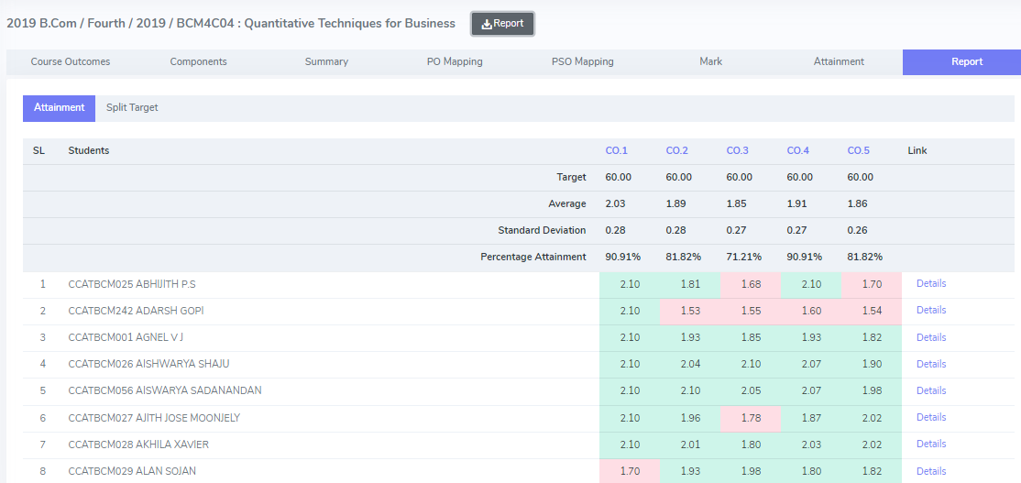

# OUTCOME ATTAINMENT CONSOLIDATED REPORT

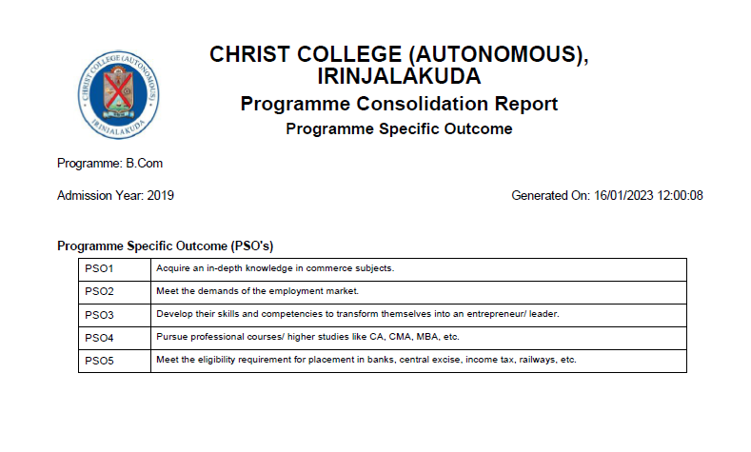



# TAXONOMY ATTAINMENT REPORT

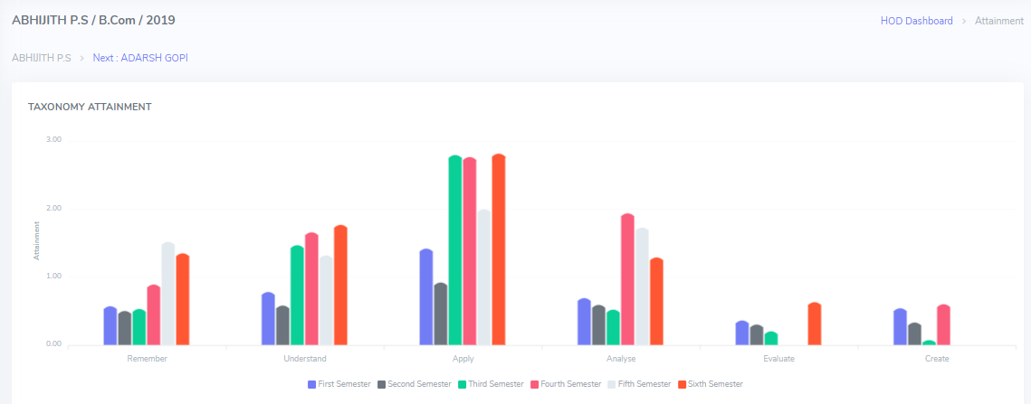

# PO ATTAINMENT REPORT

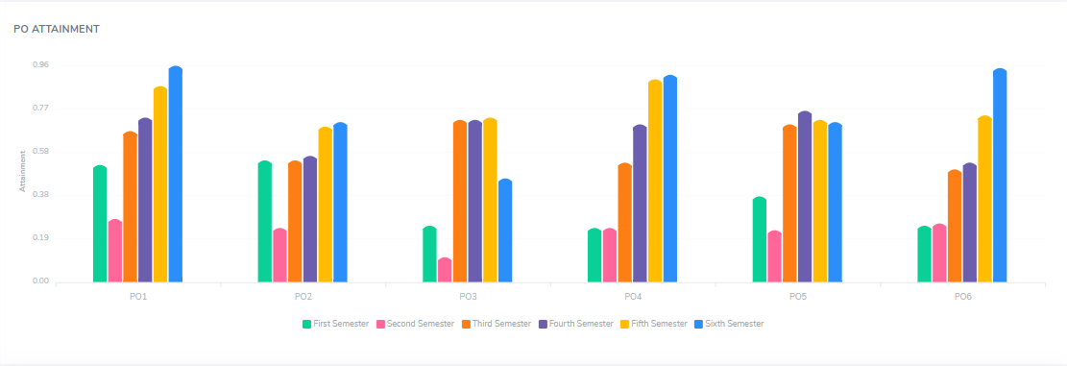

# PSO ATTAINMENT REPORT

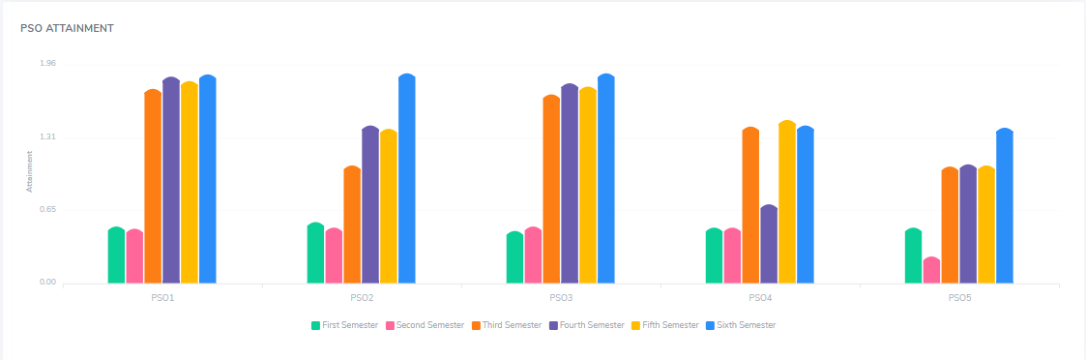

# CO ATTAINMENT REPORT

# % CO ATTAINMENT

