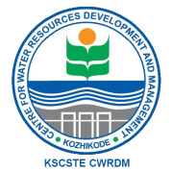

**WEBINAR**

**3R**

**on**

**"Advanced Techniques in Groundwater Resources Management"**

**July 3, 2020 at CWRDM, Kozhikode**

03.07.2020

**PARTICIPATION CERTIFICATE**

This is to certify that Roshni.K.S, Assistant Professor, Christ College (Autonomous),Irinjalakuda, Thrissur has attended the WEBINAR on "Advanced Techniques in Groundwater Resources Management held on 3rd July 2020" at CWRDM Kozhikode.

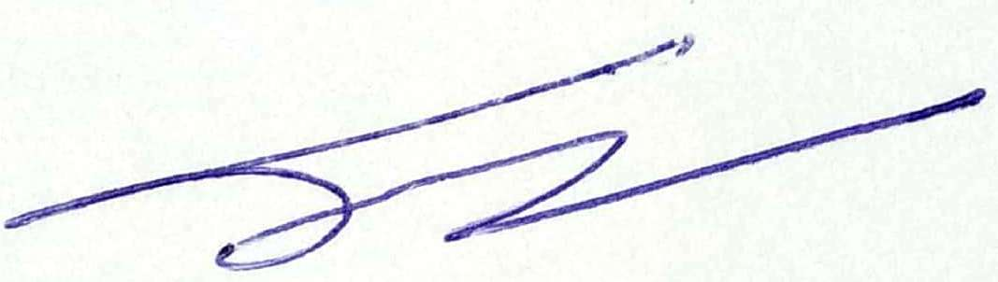

Chairman

(Er. C.M. Sushanth)

**ORGANISING COMMITTEE**

**Moderator:**

Dr.K.P.Sudheer

Executive Vice President

Kerala State Council for Science, Technology and Environment (KSCSTE)

Govt. of Kerala

Thiruvanathapuram 695004

**Speaker:**

Prof. L.Elango

Professor

Dept. of Geology  
Anna University  
Chennai 600025

**Chairpersons:**

Er. C.M.Sushanth

Senior Principal Scientist

Groundwater Division

CWRDM

Kozhikode 673571

Tel: +91 4952351854

Dr. C.P.Priju

Scientist

Groundwater Division

CWRDM

Kozhikode 673571

Dr.Arun P.R

Scientist

Groundwater Division

CWRDM

Kozhikode 673571

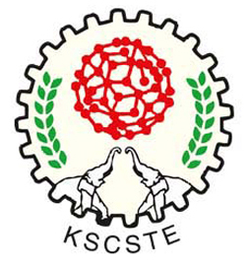

**KSCSTE-CENTRE FOR WATER RESOURCES DEVELOPMENT AND MANAGEMENT, KOZHIKODE**