OUTCOME ATTAINMENT REPORT
ADMISSION YEAR: 2020

MSC APPLIED GEOLOGY

CONTENTS
CO – PO MAPPING TABLE (SAMPLE) 2
CO – PSO MAPPING TABLE (SAMPLE) 3
OUTCOME ATTAINMENT-STUDENT (SAMPLE) 4
OUTCOME ATTAINMENT CONSOLIDATED REPORT 4
TAXONOMY ATTAINMENT REPORT 5
PO ATTAINMENT REPORT 6
PSO ATTAINMENT REPORT 7
CO ATTAINMENT REPORT PROGRAMME 8
CO ATTAINMENT REPORT 8
% CO ATTAINMENT 9

- | P a g e
O B E A t t a i n m e n t R e p o r t / 2 0 1 9 A d m / M S c A p p l i e d G e o l o g y

CO – PO MAPPING TABLE (SAMPLE)
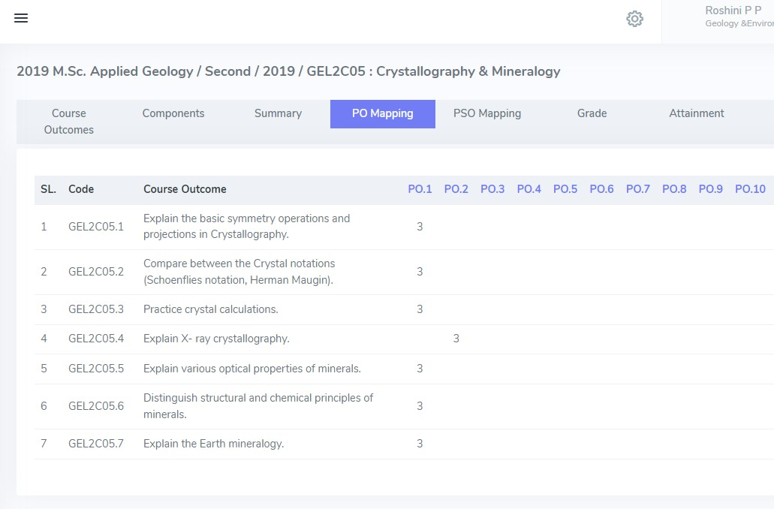

- | P a g e
O B E A t t a i n m e n t R e p o r t / 2 0 1 9 A d m / M S c A p p l i e d G e o l o g y

CO – PSO MAPPING TABLE (SAMPLE)
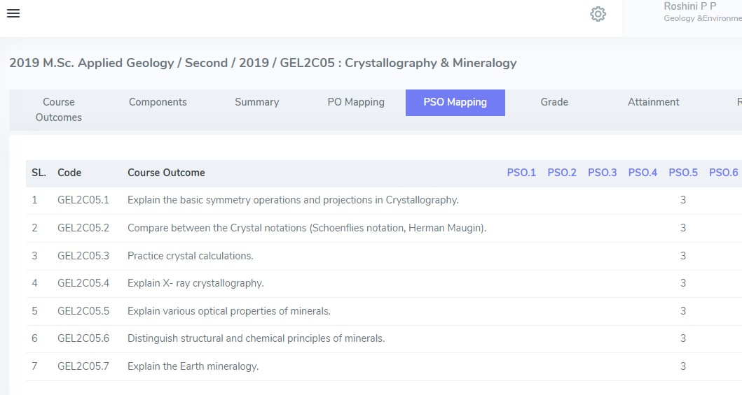

- | P a g e
O B E A t t a i n m e n t R e p o r t / 2 0 1 9 A d m / M S c A p p l i e d G e o l o g y

OUTCOME ATTAINMENT-STUDENT (SAMPLE)

OUTCOME ATTAINMENT CONSOLIDATED REPORT

- 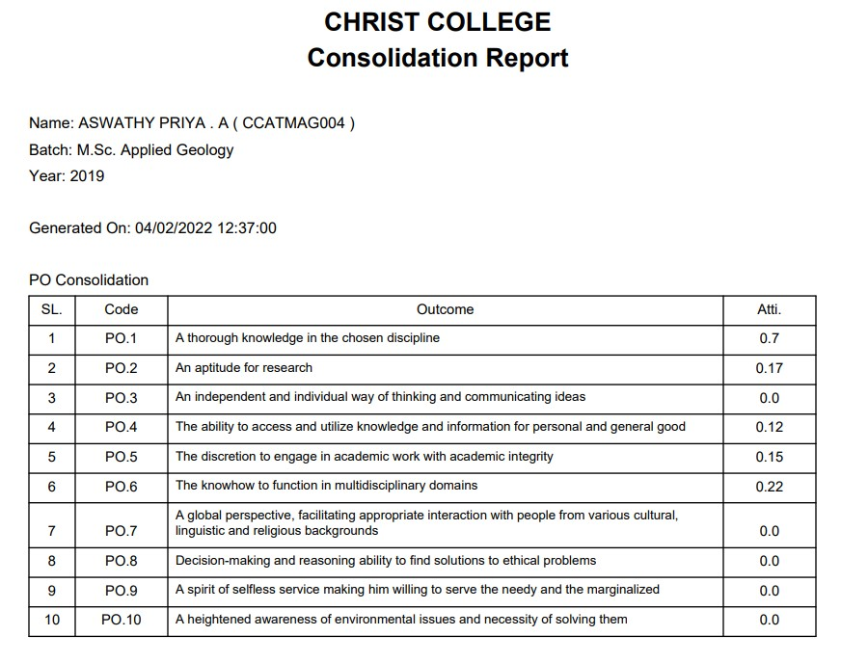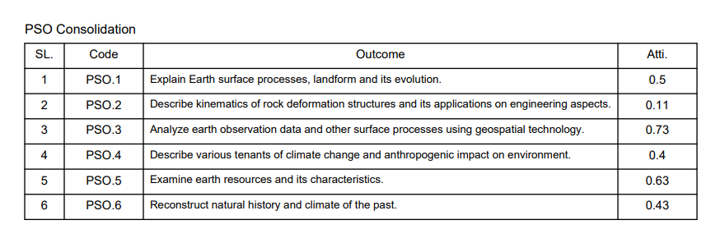| P a g e
O B E A t t a i n m e n t R e p o r t / 2 0 1 9 A d m / M S c A p p l i e d G e o l o g y

TAXONOMY ATTAINMENT REPORT

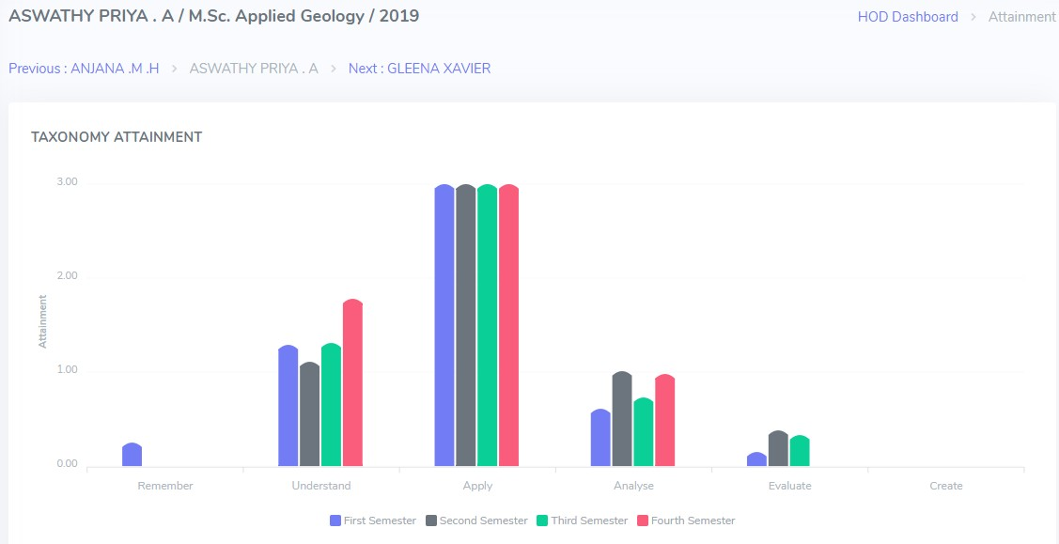

- | P a g e
O B E A t t a i n m e n t R e p o r t / 2 0 1 9 A d m / M S c A p p l i e d G e o l o g y

PO ATTAINMENT REPORT

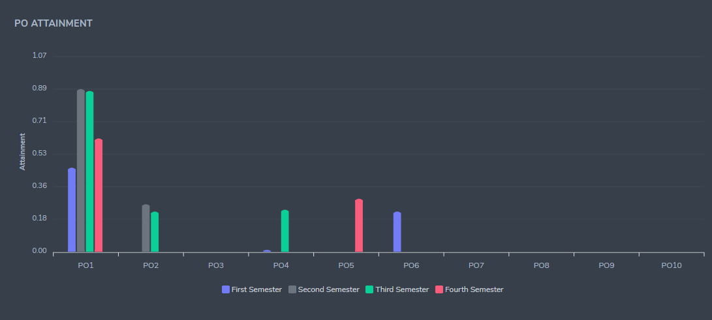

- | P a g e
O B E A t t a i n m e n t R e p o r t / 2 0 1 9 A d m / M S c A p p l i e d G e o l o g y

PSO ATTAINMENT REPORT

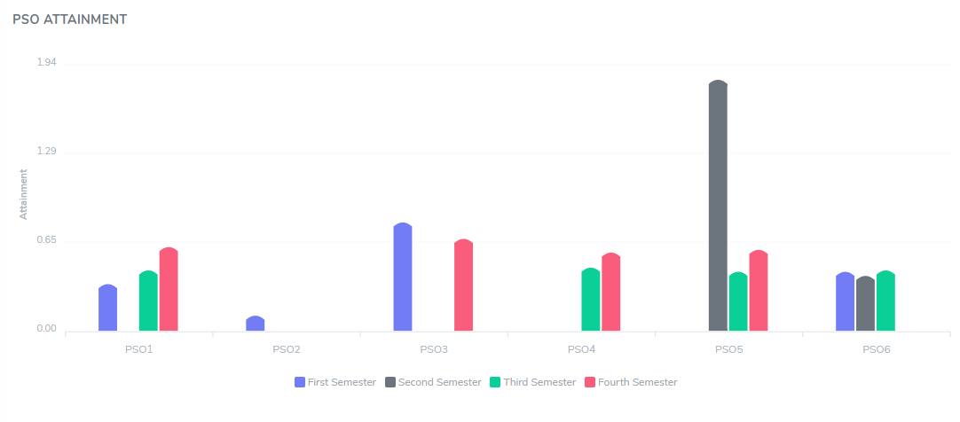

- | P a g e
O B E A t t a i n m e n t R e p o r t / 2 0 1 9 A d m / M S c A p p l i e d G e o l o g y

CO ATTAINMENT REPORT PROGRAMME

CO ATTAINMENT REPORT

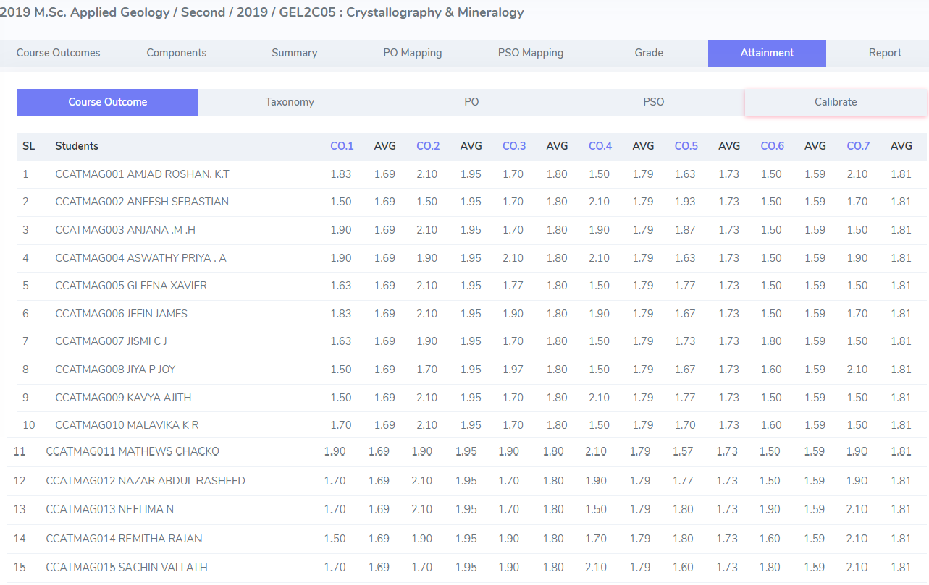
- | P a g e
O B E A t t a i n m e n t R e p o r t / 2 0 1 9 A d m / M S c A p p l i e d G e o l o g y

% CO ATTAINMENT

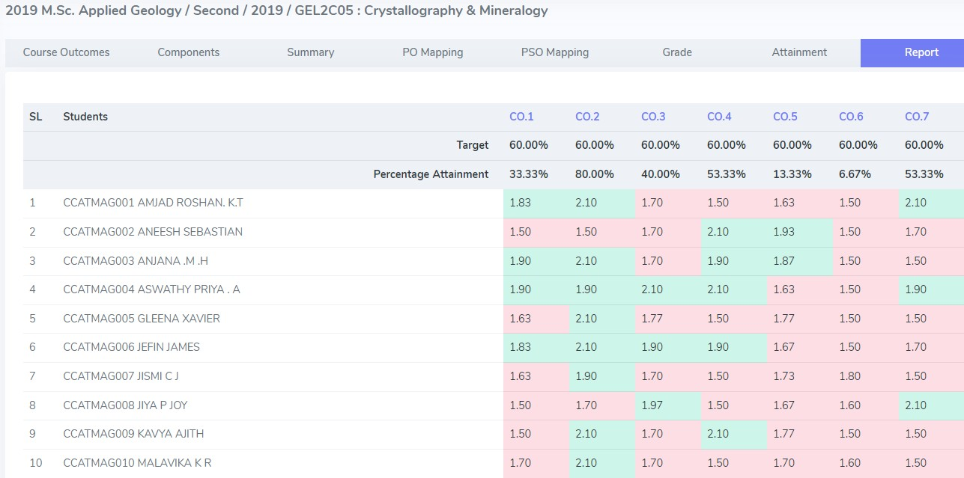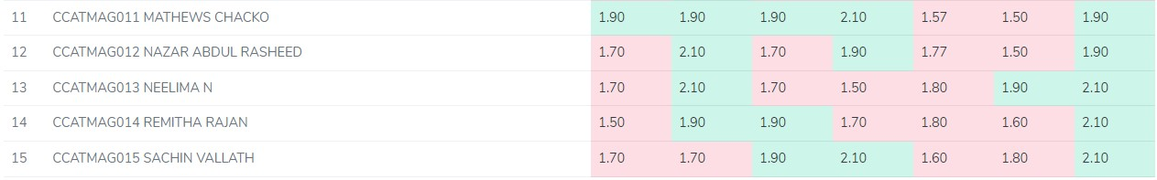
- | P a g e
O B E A t t a i n m e n t R e p o r t / 2 0 1 9 A d m / M S c A p p l i e d G e o l o g y

