OUTCOME ATTAINMENT REPORT
ADMISSION YEAR: 2020

MSC CHEMISTRY

CONTENTS
CO – PO MAPPING TABLE (SAMPLE) 2
CO – PSO MAPPING TABLE (SAMPLE) 3
OUTCOME ATTAINMENT-STUDENT (SAMPLE) 4
OUTCOME ATTAINMENT CONSOLIDATED REPORT 4
TAXONOMY ATTAINMENT REPORT 5
PO ATTAINMENT REPORT 6
PSO ATTAINMENT REPORT 7
CO ATTAINMENT REPORT PROGRAMME 8
CO ATTAINMENT REPORT 8
% CO ATTAINMENT 9

- | P a g e
O B E A t t a i n m e n t R e p o r t / 2 0 1 9 A d m / M S c C h e m i s t r y

CO – PO MAPPING TABLE (SAMPLE)

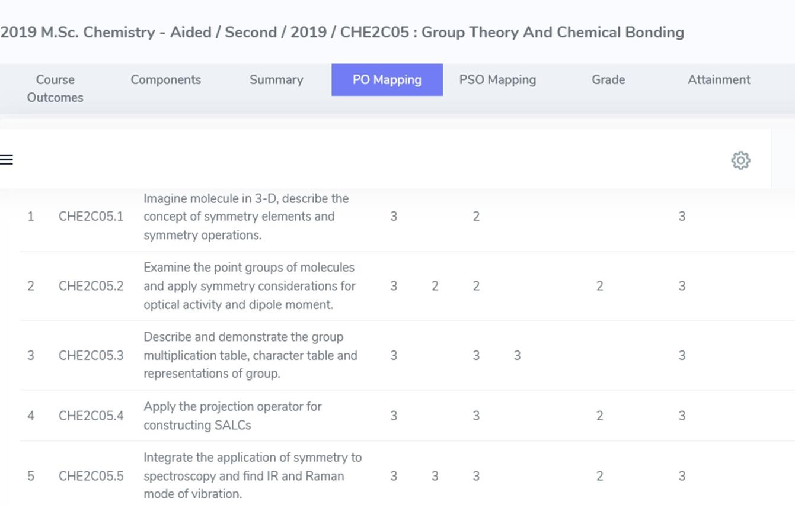

- | P a g e
O B E A t t a i n m e n t R e p o r t / 2 0 1 9 A d m / M S c C h e m i s t r y

CO – PSO MAPPING TABLE (SAMPLE)

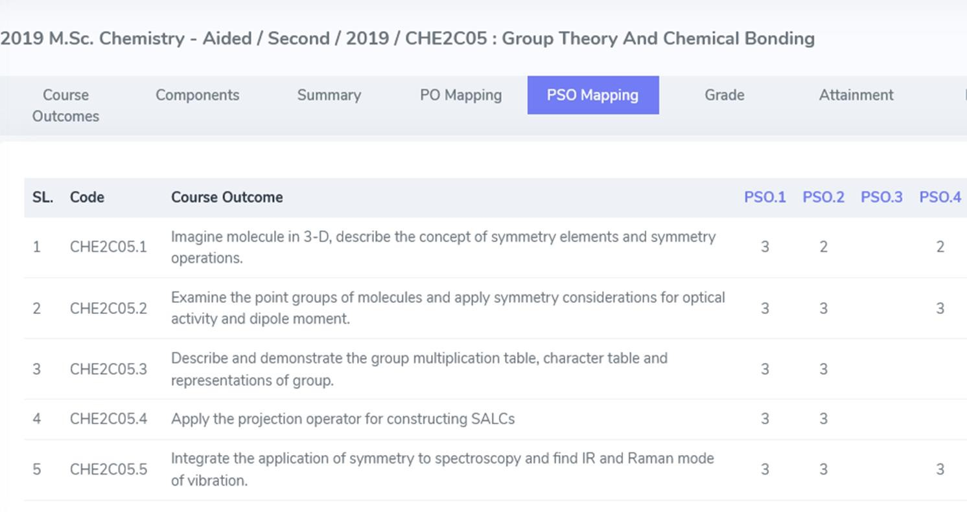

- | P a g e
O B E A t t a i n m e n t R e p o r t / 2 0 1 9 A d m / M S c C h e m i s t r y

OUTCOME ATTAINMENT-STUDENT (SAMPLE)

OUTCOME ATTAINMENT CONSOLIDATED REPORT

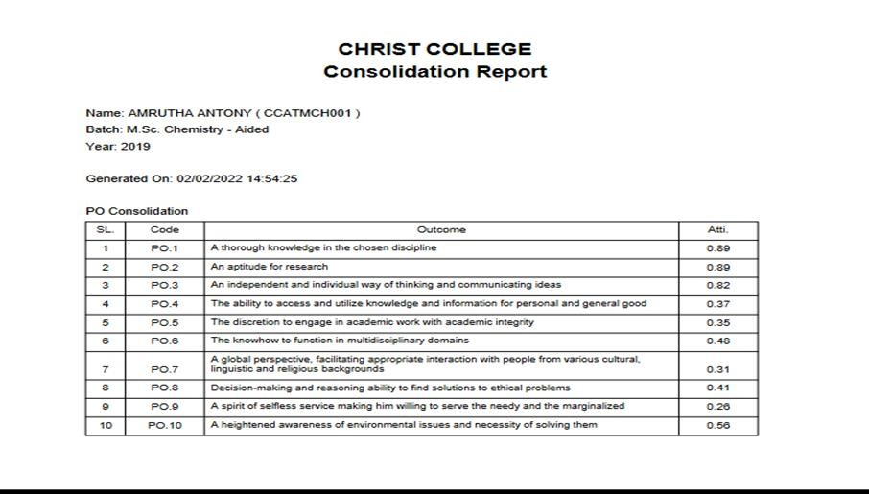
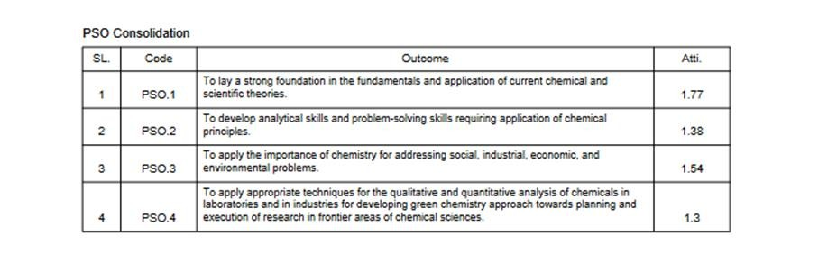

- | P a g e
O B E A t t a i n m e n t R e p o r t / 2 0 1 9 A d m / M S c C h e m i s t r y

TAXONOMY ATTAINMENT REPORT

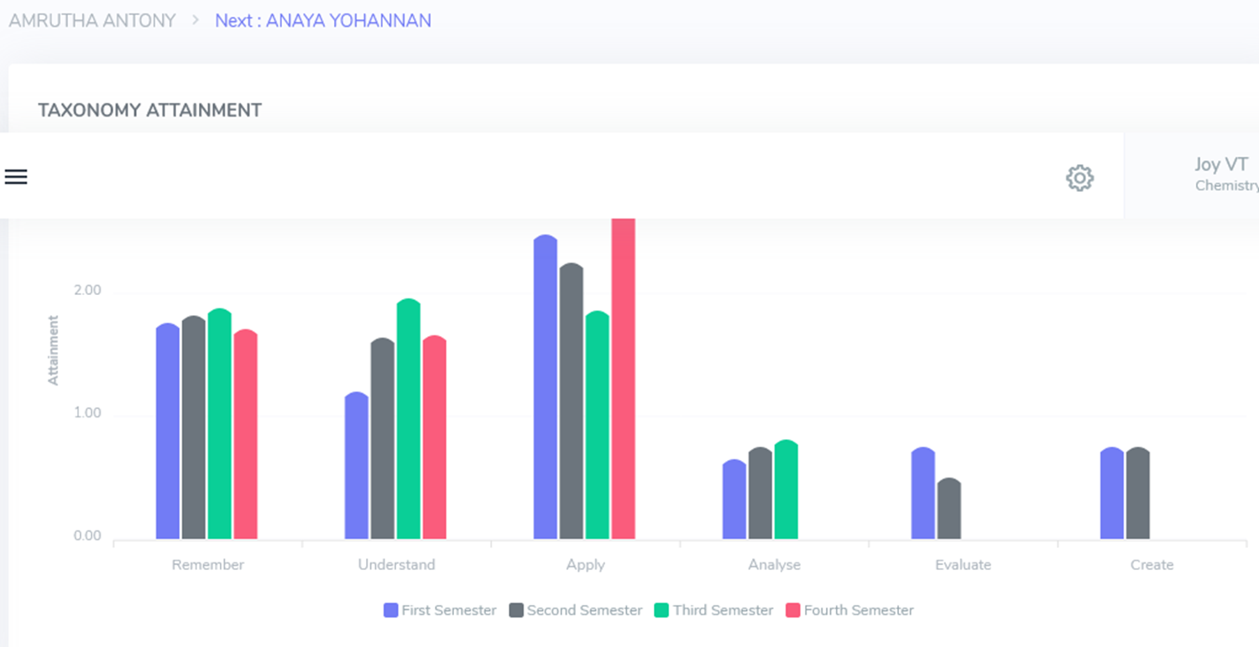

- | P a g e
O B E A t t a i n m e n t R e p o r t / 2 0 1 9 A d m / M S c C h e m i s t r y

PO ATTAINMENT REPORT

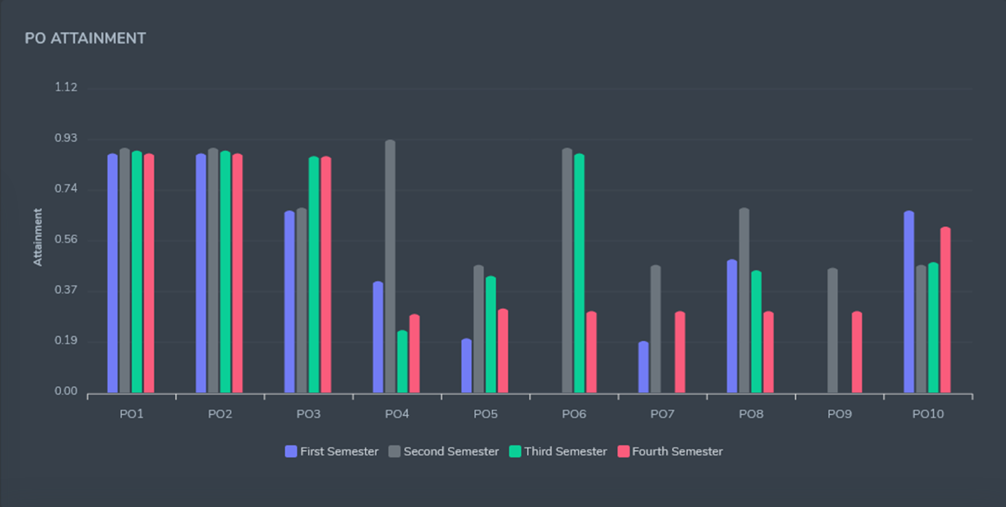

- | P a g e
O B E A t t a i n m e n t R e p o r t / 2 0 1 9 A d m / M S c C h e m i s t r y

PSO ATTAINMENT REPORT

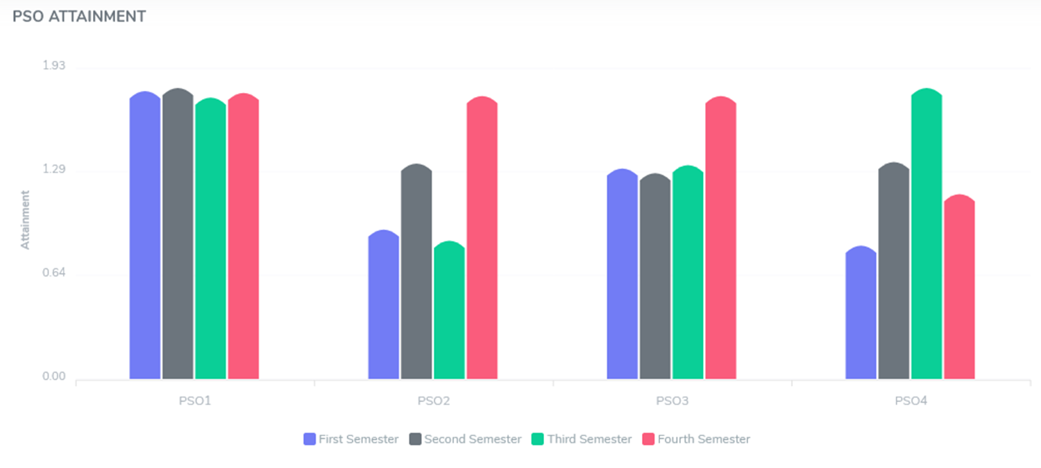

- | P a g e
O B E A t t a i n m e n t R e p o r t / 2 0 1 9 A d m / M S c C h e m i s t r y

CO ATTAINMENT REPORT PROGRAMME

CO ATTAINMENT REPORT

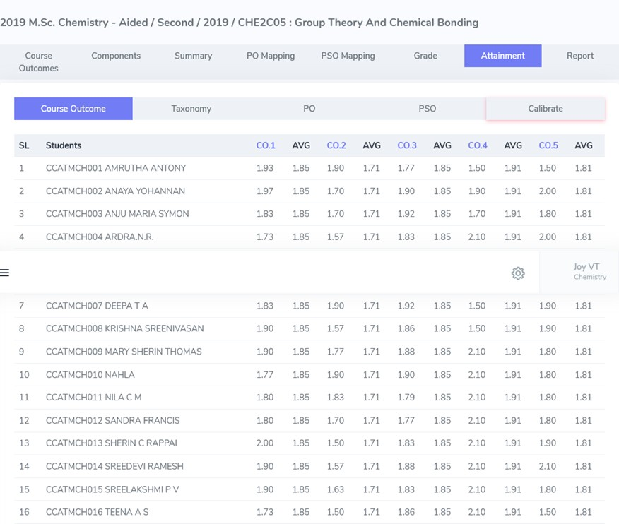

- | P a g e
O B E A t t a i n m e n t R e p o r t / 2 0 1 9 A d m / M S c C h e m i s t r y

% CO ATTAINMENT

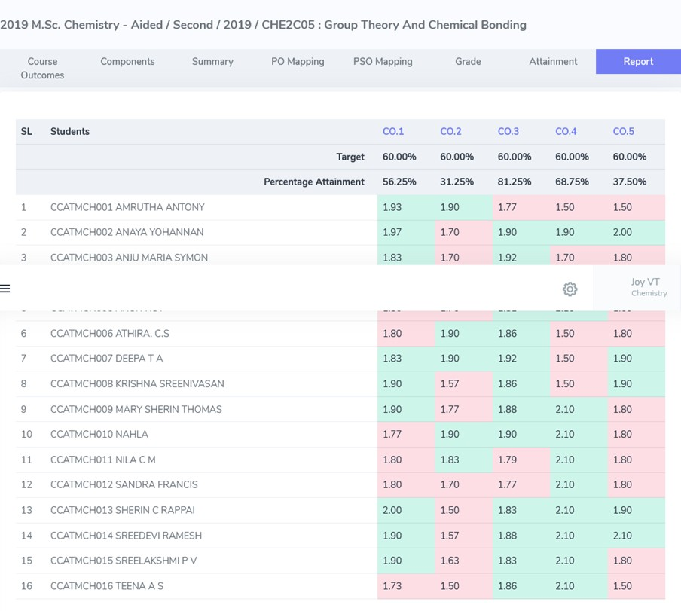

- | P a g e
O B E A t t a i n m e n t R e p o r t / 2 0 1 9 A d m / M S c C h e m i s t r y

