OUTCOME ATTAINMENT REPORT
ADMISSION YEAR: 2020

MSC PHYSICS

CONTENTS
CO – PO MAPPING TABLE (SAMPLE) 2
CO – PSO MAPPING TABLE (SAMPLE) 3
OUTCOME ATTAINMENT-STUDENT (SAMPLE) 4
OUTCOME ATTAINMENT CONSOLIDATED REPORT 4
TAXONOMY ATTAINMENT REPORT 6
PO ATTAINMENT REPORT 7
PSO ATTAINMENT REPORT 8
CO ATTAINMENT REPORT PROGRAMME 9
CO ATTAINMENT REPORT 9
% CO ATTAINMENT 10

- | P a g e
O B E A t t a i n m e n t R e p o r t / 2 0 1 9 A d m / M S c P h y s i c s

CO – PO MAPPING TABLE (SAMPLE)

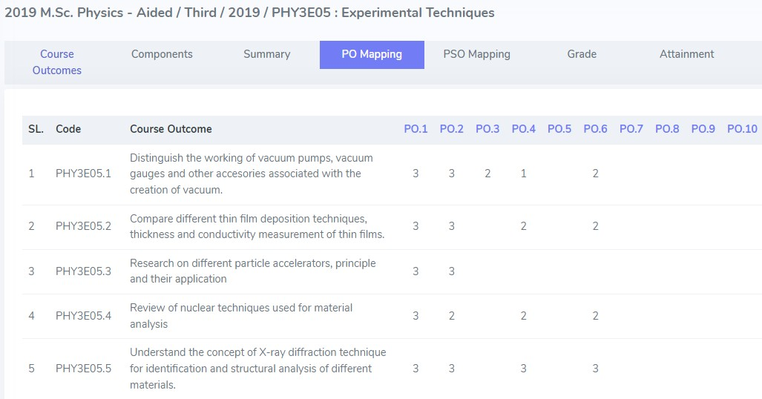

- | P a g e
O B E A t t a i n m e n t R e p o r t / 2 0 1 9 A d m / M S c P h y s i c s

CO – PSO MAPPING TABLE (SAMPLE)

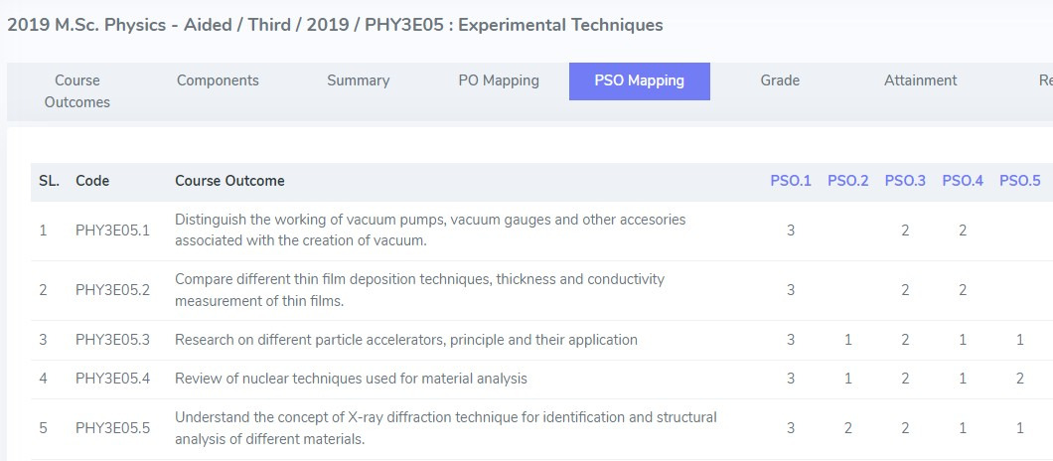

- | P a g e
O B E A t t a i n m e n t R e p o r t / 2 0 1 9 A d m / M S c P h y s i c s

OUTCOME ATTAINMENT-STUDENT (SAMPLE)

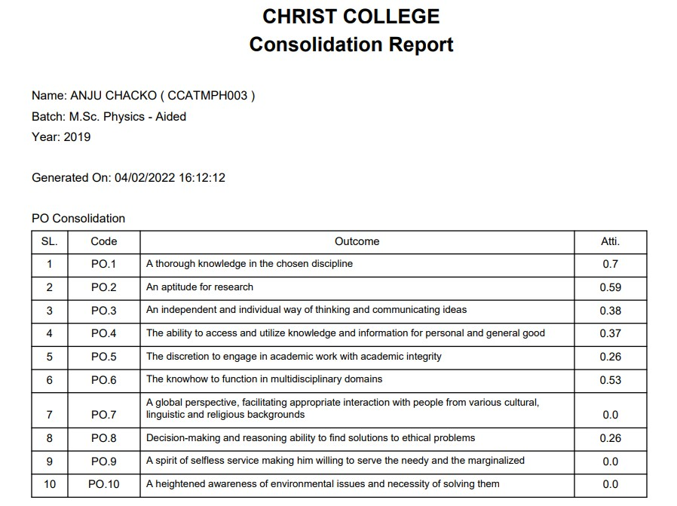
OUTCOME ATTAINMENT CONSOLIDATED REPORT

- | P a g e
O B E A t t a i n m e n t R e p o r t / 2 0 1 9 A d m / M S c P h y s i c s

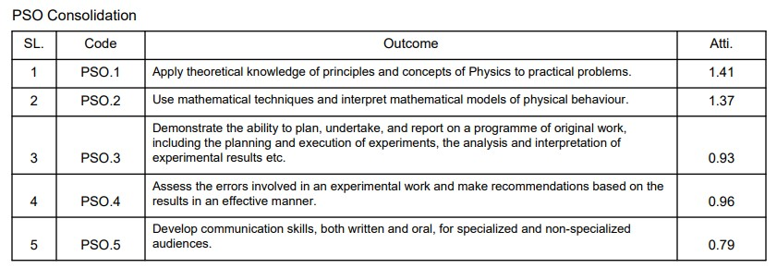

- | P a g e
O B E A t t a i n m e n t R e p o r t / 2 0 1 9 A d m / M S c P h y s i c s

TAXONOMY ATTAINMENT REPORT

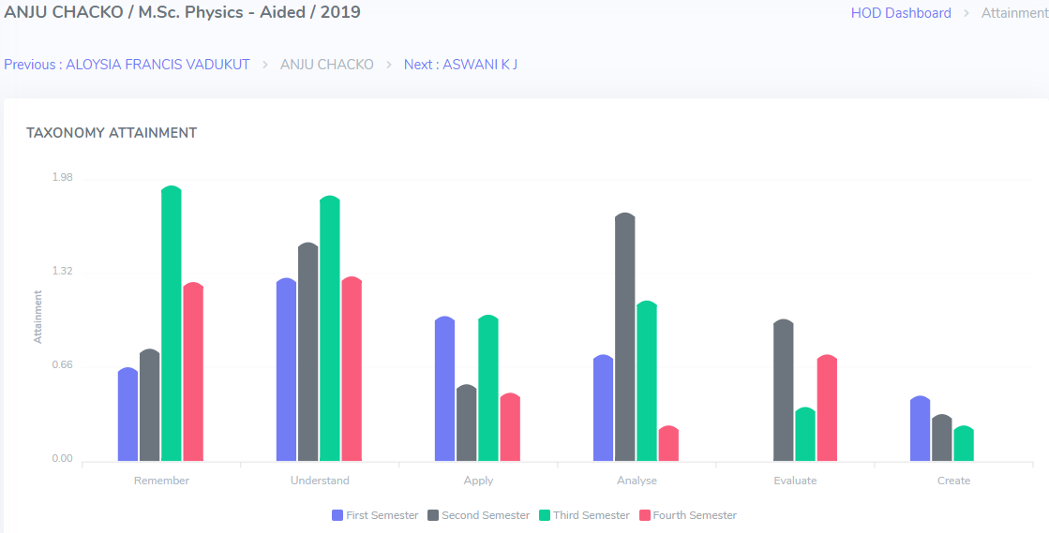

- | P a g e
O B E A t t a i n m e n t R e p o r t / 2 0 1 9 A d m / M S c P h y s i c s

PO ATTAINMENT REPORT

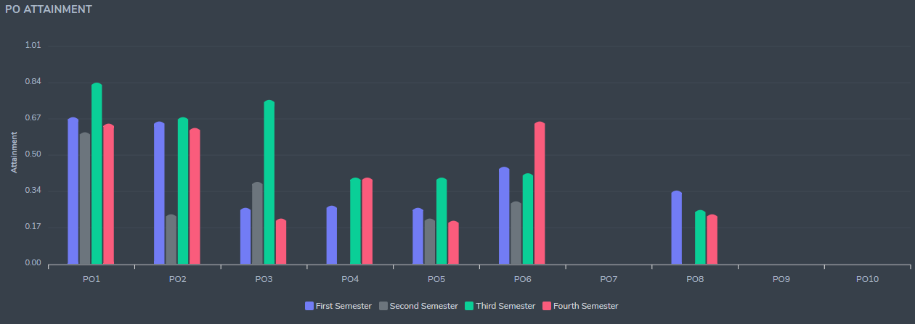

- | P a g e
O B E A t t a i n m e n t R e p o r t / 2 0 1 9 A d m / M S c P h y s i c s

PSO ATTAINMENT REPORT

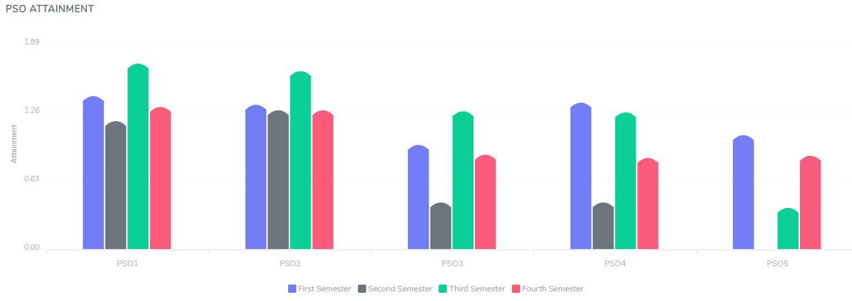

- | P a g e
O B E A t t a i n m e n t R e p o r t / 2 0 1 9 A d m / M S c P h y s i c s

CO ATTAINMENT REPORT PROGRAMME

CO ATTAINMENT REPORT

- 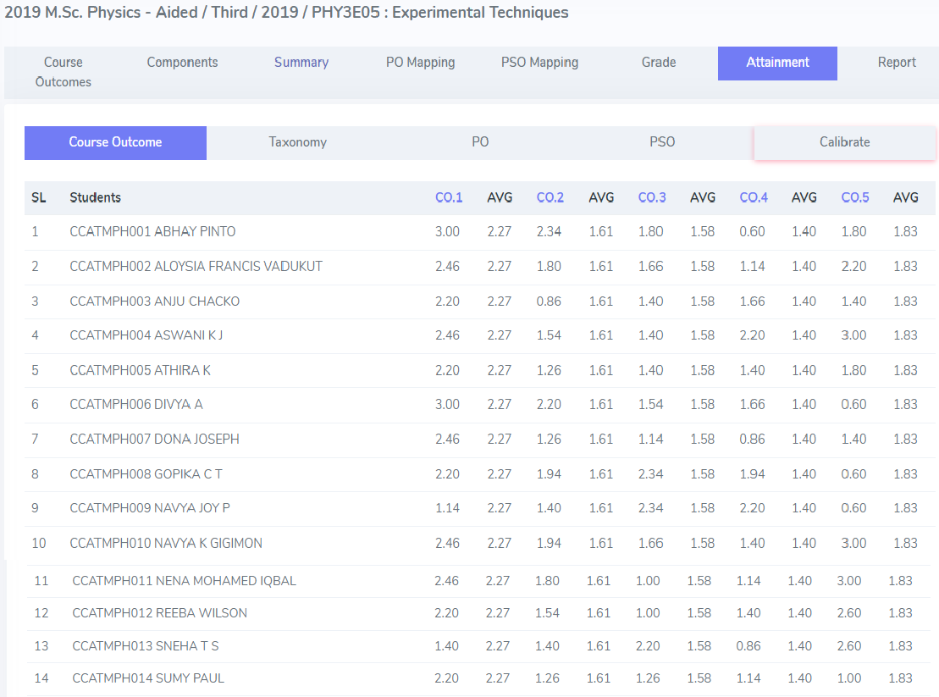| P a g e
O B E A t t a i n m e n t R e p o r t / 2 0 1 9 A d m / M S c P h y s i c s

% CO ATTAINMENT

- 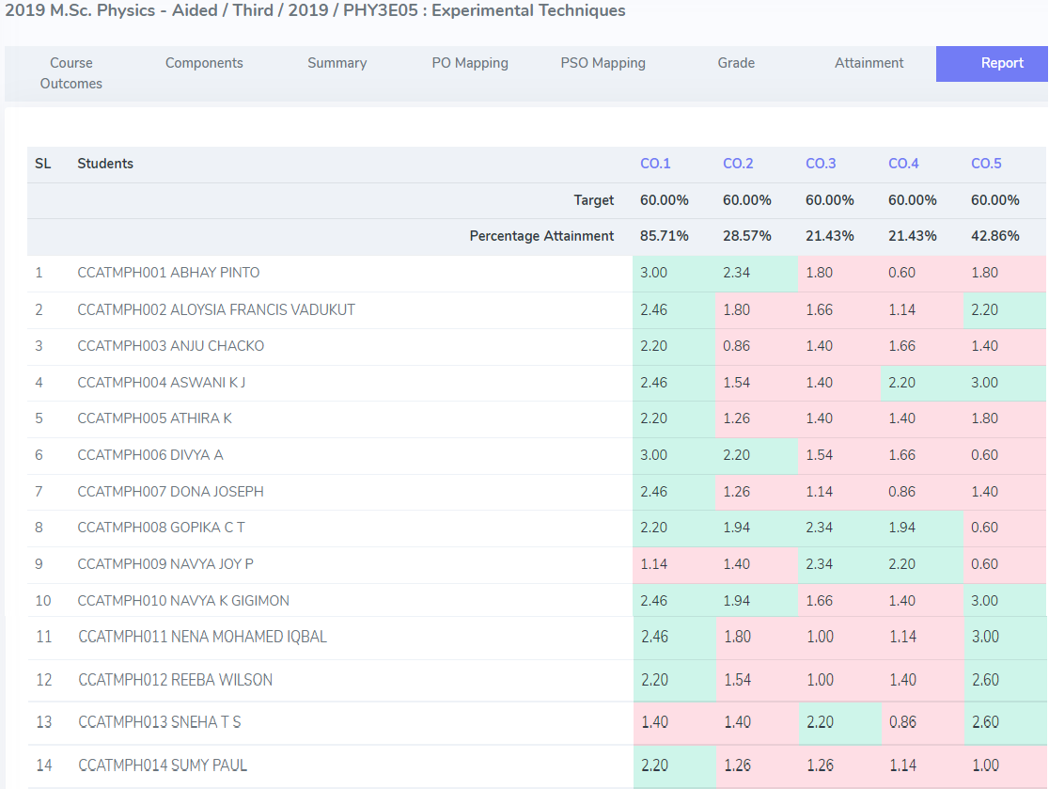| P a g e
O B E A t t a i n m e n t R e p o r t / 2 0 1 9 A d m / M S c P h y s i c s

