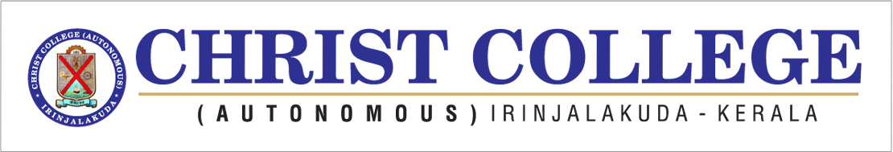
INTERNATIONAL CONFERENCE ON MARKET LIQUIDITY AND SUSTAINABLE DEVELOPMENT TOWARDS KNOWLEDGE SOCIETY
On
14th-15th DECEMBER, 2018
PROGRAMME SCHEDULE - INAUGURAL SESSION
14th DECEMBER 2018
9:30 a m Prayer
9:33 a m Welcome Address :Rev. Dr.JOLLY ANDREWS CMI
(Vice Principal, Christ College (Autonomous))
9:43 a m Presidential Address :Dr. MATHEW PAUL UKKEN
(Principal, Christ College (Autonomous))
9:50 a m Benedictory Address : REV. FR. JACOB NJERINJAMPILLY CMI
(Manager, Christ College (Autonomous))
9:57a m Lighting The Lamp
10:00 a m Introducing Guest of Honour :Prof .Dr. JOSE NANDIKKARA CMI
Prof. Dr.Thomas Pogge (Professor in Philosophy, Christ University, Bangalore)

10:15 a m Inaugural Address :Prof. Dr. THOMAS POGGE- ‘The Health Impact Fund-Enhancing Justice and Efficiency in Global Health’
(Professor in Philosophy and International Affairs, Yale University, USA)
11:15 a m Interaction Session
11:30 a m Introducing Keynote Speaker :Prof. P A VARGHESE
Prof. Dr. P Krishna Prasanna (Head, P G Dept of Commerce, Christ College (Autonomous))

11: 35a m Keynote Address : Prof.Dr. P.KRISHNA PRASANNA- ‘Market
Liquidity’
(Professor, Finance, Dept. of Management Studies, IIT Madras)
12: 35 p m Interaction Session
12:45p m Presentation of Mementos
12: 55 p m Vote of Thanks : Prof. MUVISH K M
(Conference Coordinator)
1:00 p m Photo Session
Lunch Break

