Speakers
Guest of Honor – Dr. Prof. Thomas Winfried MenkoPogge
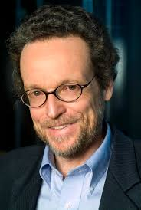 Dr. Poggeis theProfessor of Philosophy and International Affairs at Yale University. In addition to his Yale appointment, he is the Research Director of the Centre for the Study of the Mind in Nature at the University of Oslo and Director of the Global Justice Program. Pogge is also an editor for social and political philosophy for the Stanford Encyclopedia of Philosophy and a member of the Norwegian Academy of Science and Letters. He has authored more than 13 books ranging from poverty to human rights.
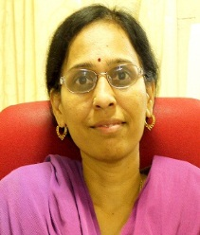Dr. P. Krishna Prasannais the Professor with Department of Management Studies, Indian Institute of Technology, Madras. She has published papers in international journals and has won bets paper awards in conferences conducted across India. Her research interests include Corporate Governance, Stock Market Analysis and Corporate Finance.
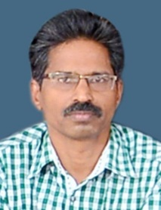Dr. E. Muraliis Associate Professor in PG Deptof Commerce and Managemen
Studies, Sri C AchuthaMenon Government College,Thrissur. He is currently serving as head of the
department in the institution. He serves as member in Board of Studies of University of Calicut and
various other autonomous colleges. He has published in various national and international journals.

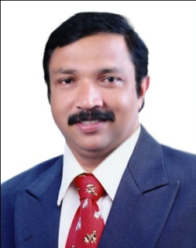 Dr. T. G Saji is an Associate Professor in PG Dept of Commerce and Management
Studies, Sri C AchuthaMenon Government College,Thrissur. He has national and international
publications to his credit in areas of stock returns and earnings growth. He has authored books and is
acting as a research Guide with University of Calicut and Bharathiyar University. His research interests include global business and finance and his prime research focus is on asset pricing and firms' valuation. He teaches quantitative techniques, security analysis, financial derivatives and direct tax. He has been invited speaker on data analytics and investment finance in more than 60 National and International seminars/workshops and is able to publish research papers in around 50 (Scopus indexed/ABDC rated) journals.

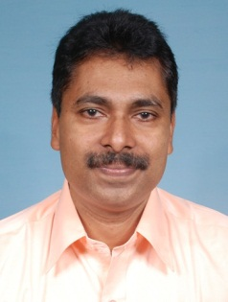
Dr. E.M Thomas is serving as General Secretary of Kerala Economic Association and Co-ordinator of
InterUniversity Centre for Financial Economics and Financial Engineering, University of Calicut.

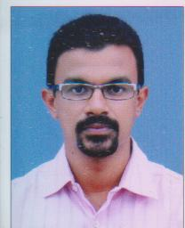Mr. Joseph P Abrahamis a business development professional with over 18 years of experience in financial markets. He is the National Business Head of Acumen Capital Markets India Limited. He has served as a domain expert lecturer in various MBA institutes.
Mr. Geordie Job Pottas is a SEBI Qualified Equity Analyst and an ex-banker. He has earned his MBA from IIM-K. He is stock market investor since 2008 and is associated with Finmark Trainers as a investment advisor and trainer.

