Events Organized
Objective
To create awareness about the Job Prospects among students.

- CMA Profinz in association with Christ College (Autonomous) Irinjalakuda organized a webinar on Course Awareness & Job Prospects of cost & Management Accountancy on 15 Dec 2020.
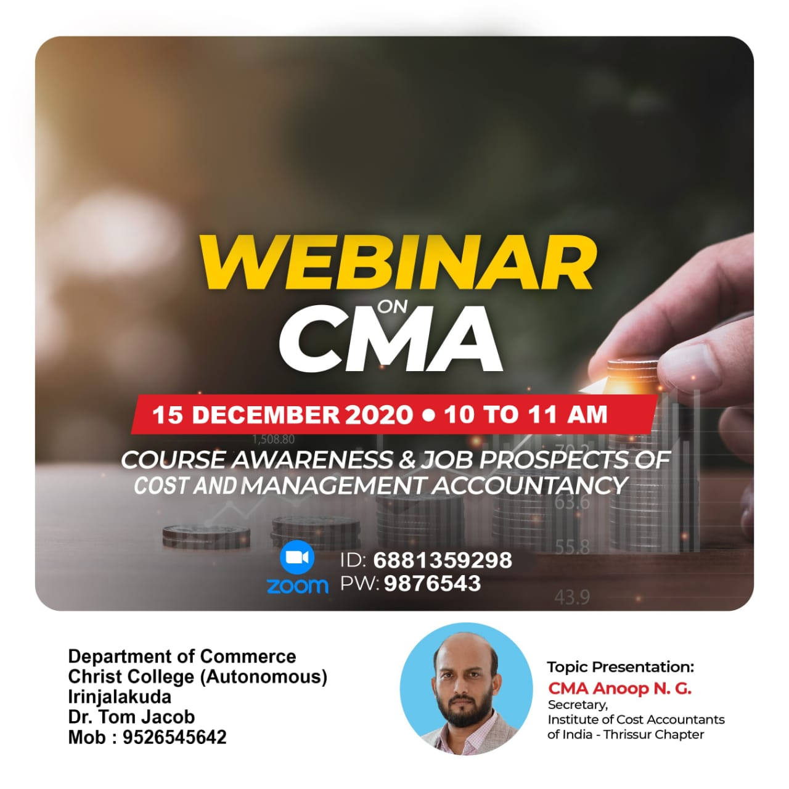
2. T.I.M.E Institute in association with Christ College (Autonomous) Irinjalakuda conducted Free model aptitude Test on 27-Dec-2020
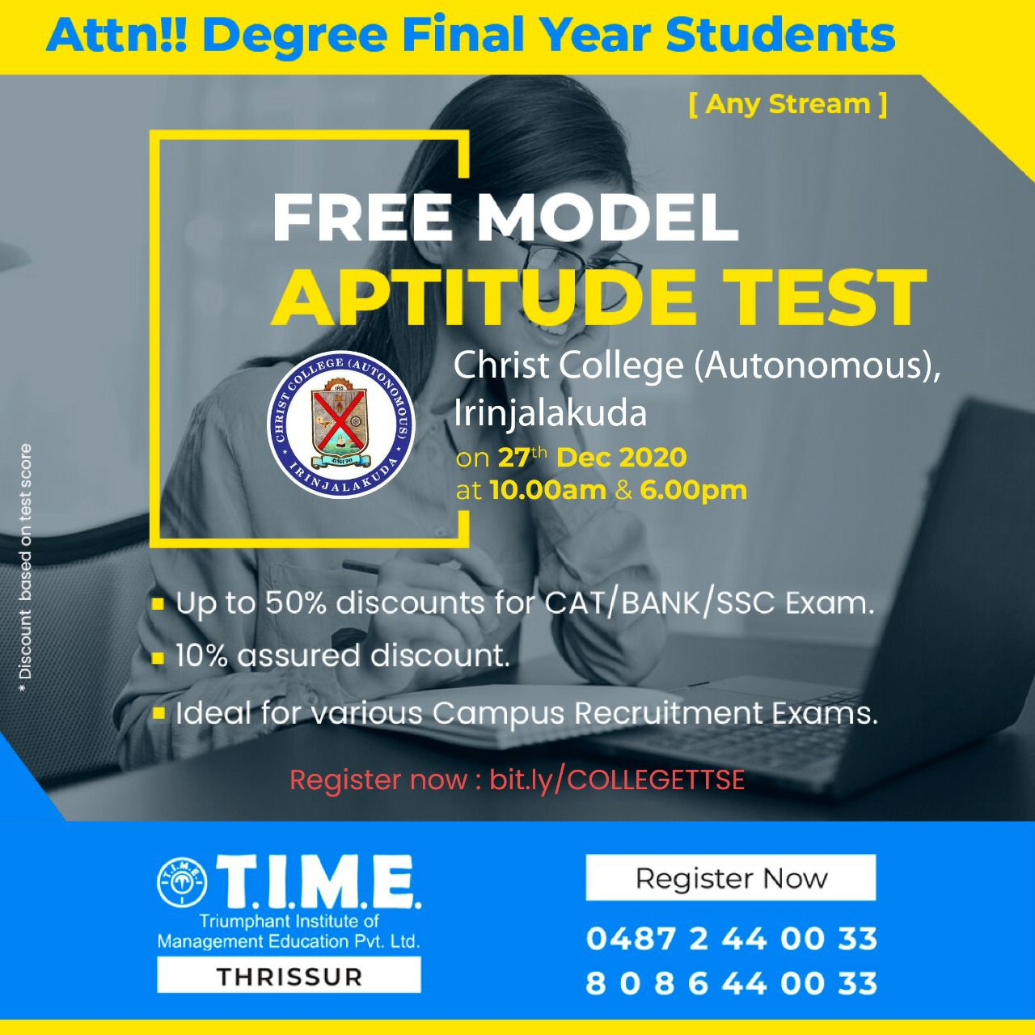

- NCVRT in association with Christ College (Autonomous) Irinjalakuda organized a webinar on Practical accounting & Tax Practice on 30-12-2020
